IIT Jammu Summer School 2026

Tittle
Project-9:Stepper Motor Precision Positioner using Arduino Uno (Simulation using Wokwi)
Submitted By
Name: RUBADHARSHINI S
Department: Electronics and Communication Engineering
College: Arjun College of Technology
Course: IoT & Drones

Aim
To design and simulate a precision stepper motor position control system using Arduino Uno in the Wokwi simulation environment. The project allows the user to control the motor position using a potentiometer and push buttons while displaying the current status on an OLED display.

Abstract
The Stepper Motor Precision Positioner is an embedded systems project developed using Arduino Uno and simulated using the Wokwi online simulator. The project demonstrates accurate position control of a stepper motor through a potentiometer and push buttons. The potentiometer sets the desired target angle, while dedicated buttons rotate the motor clockwise and counter-clockwise. A Home button resets the logical motor position. An OLED display continuously shows the current angle, target angle, motor direction, and step count. This project demonstrates the basic working principles of motion control systems used in CNC machines, robotic arms, and automated industrial equipment.

Introduction
Stepper motors are widely used in automation because they provide accurate rotational movement without requiring additional position sensors. Each electrical pulse moves the motor by a fixed angle, making it suitable for precision applications. In this project, the entire hardware system is simulated using Wokwi, enabling software testing and debugging without physical hardware.

Problem Statement
Industrial machines require precise positioning of motors for accurate operation. Manual positioning is time-consuming and inaccurate. This project develops a precision position controller that allows users to set target positions, move the motor in both directions, and monitor motor status through an OLED display.

Objectives
- To simulate a stepper motor control system using Wokwi.
- To interface a stepper motor with Arduino Uno.
- To control motor movement using push buttons.
- To set the target angle using a potentiometer.
- To display motor information on an OLED display.
- To implement a Home position function.
- To monitor motor position through the Serial Monitor.

Software Used
Software | Purpose
Arduino IDE | Writing Arduino Program
Wokwi Simulator | Hardware Simulation
GitHub | Project Repository
Microsoft Word | Documentation

Components Used
Component | Quantity
Arduino Uno | 1
Stepper Motor (Simulated) | 1
OLED Display SSD1306 | 1
Potentiometer | 1
Push Buttons | 3
LED | 1
Jumper Wires | As Required
Wokwi Simulator | 1

Simulation Platform
Wokwi Simulator
This project was developed and tested using the Wokwi online simulator. Wokwi provides a virtual Arduino environment where electronic components such as stepper motors, OLED displays, LEDs, potentiometers, and push buttons can be simulated without requiring physical hardware.
The simulator enables testing of Arduino programs, verification of circuit connections, and observation of outputs through the Serial Monitor and OLED display.

Circuit Description
The Arduino Uno serves as the main controller of the project. The potentiometer is connected to the analog input to generate a target angle between 0° and 360°. Three push buttons are connected to digital input pins to control clockwise rotation, counter-clockwise rotation, and Home position reset. The OLED display communicates through the I²C interface and continuously displays motor information. The LED acts as a position indicator during motor movement. The stepper motor is driven through the Arduino using the Stepper library.

Hardware Connections
Component | Arduino Pin

Potentiometer | A0

CW Button | D2

CCW Button | D3

Home Button | D4

LED | D7

Stepper Motor IN1 | D8

Stepper Motor IN2 | D9

Stepper Motor IN3 | D10

Stepper Motor IN4 | D11

OLED SDA | A4

OLED SCL | A5

Working Principle
The Arduino continuously reads the potentiometer value and converts it into a target angle ranging from 0° to 360°. When the Clockwise button is pressed, the stepper motor rotates by a fixed number of steps in the clockwise direction. Similarly, pressing the Counter-Clockwise button rotates the motor in the opposite direction. The Home button resets the logical motor position to zero without physically rotating the motor. The OLED display updates the current angle, target angle, motor direction, and step count in real time. The Serial Monitor logs every movement for debugging and monitoring.

Algorithm
- Start the system.
- Initialize Arduino Uno and OLED display.
- Read the potentiometer value.
- Convert the analog value into a target angle.
- Check the Clockwise button.
- If pressed, rotate the motor clockwise.
- Check the Counter-Clockwise button.
- If pressed, rotate the motor counter-clockwise.
- Check the Home button.
- Reset the current position if Home is pressed.
- Update the OLED display.
- Display the motor status on the Serial Monitor.
- Repeat continuously.

Flowchart
Start
│
Initialize System
│
Read Potentiometer
│
Read Push Buttons
│
Rotate Stepper Motor
│
Update Step Count
│
Update OLED Display
│
Print Serial Output
│
Repeat

Program
#include <Wire.h>
#include <Adafruit_GFX.h>
#include <Adafruit_SSD1306.h>
#include <Stepper.h>
#define SCREEN_WIDTH 128
#define SCREEN_HEIGHT 64
Adafruit_SSD1306 display(SCREEN_WIDTH, SCREEN_HEIGHT, &Wire, -1);
const int STEPS_PER_REV = 2048;
Stepper motor(STEPS_PER_REV, 8, 10, 9, 11);
const int potPin = A0;
const int cwBtn = 2;
const int ccwBtn = 3;
const int homeBtn = 4;
const int ledPin = 7;
long currentSteps = 0;
String direction = "STOP";
void setup() {
Serial.begin(9600);
pinMode(cwBtn, INPUT_PULLUP);
pinMode(ccwBtn, INPUT_PULLUP);
pinMode(homeBtn, INPUT_PULLUP);
pinMode(ledPin, OUTPUT);
motor.setSpeed(10);
if(!display.begin(SSD1306_SWITCHCAPVCC,0x3C)){
while(true);
}
display.clearDisplay();
display.display();
}
void loop() {
int pot = analogRead(potPin);
int targetAngle = map(pot,0,1023,0,360);
float currentAngle = fmod(currentSteps * 360.0 / STEPS_PER_REV,360);
if(currentAngle < 0)
currentAngle += 360;
if(digitalRead(cwBtn)==LOW){
motor.step(256);
currentSteps += 256;
direction = "CW";
delay(250);
}
if(digitalRead(ccwBtn)==LOW){
motor.step(-256);
currentSteps -= 256;
direction = "CCW";
delay(250);
}
if(digitalRead(homeBtn)==LOW){
currentSteps = 0;
direction = "HOME";
delay(250);
}
digitalWrite(ledPin, HIGH);
display.clearDisplay();
display.setTextSize(1);
display.setTextColor(SSD1306_WHITE);
display.setCursor(0,0);
display.print("Current:");
display.print((int)currentAngle);
display.println(" deg");
display.print("Target :");
display.print(targetAngle);
display.println(" deg");
display.print("Steps :");
display.println(currentSteps);
display.print("Dir :");
display.println(direction);
display.display();
Serial.print("Current Angle : ");
Serial.print(currentAngle);
Serial.print(" | Target : ");
Serial.print(targetAngle);
Serial.print(" | Steps : ");
Serial.print(currentSteps);
Serial.print(" | Direction : ");
Serial.println(direction);
delay(100);
}

Program Explanation
The program begins by initializing the OLED display and stepper motor. The potentiometer value is continuously read through the analog pin and converted into the target angle. Push buttons are configured using the INPUT_PULLUP mode. When a button is pressed, the motor rotates by a predefined number of steps. The program keeps track of the current motor position and converts the total steps into an angular position. The OLED display is refreshed with the latest information, while the Serial Monitor prints the current status for debugging.

Simulation Output
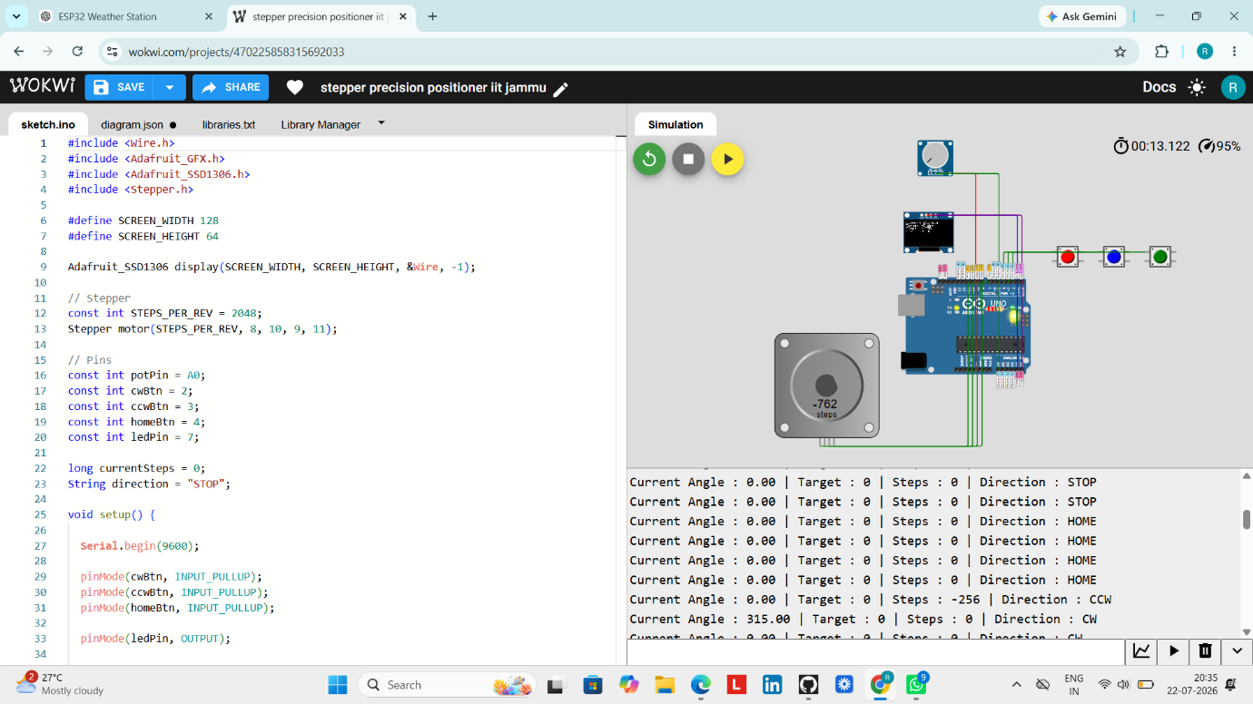
Figure 1: Wokwi Simulation of Stepper Motor Precision Positioner

Applications
- CNC Machines
- 3D Printers
- Robotic Arms
- Camera Positioning Systems
- Pick-and-Place Robots
- Industrial Automation
- Conveyor Control Systems

Advantages
- High positioning accuracy
- Easy to simulate using Wokwi
- Cost-effective learning platform
- Real-time OLED monitoring
- Simple user interface
- Easy to modify and expand

Future Scope
- Wireless control using ESP32 and Wi-Fi
- Mobile application control
- Rotary encoder feedback
- IoT-based monitoring
- Cloud data logging
- Voice-controlled positioning

Conclusion
The Stepper Motor Precision Positioner project was successfully designed and simulated using the Wokwi platform. The system accurately controls the motor position through user inputs and provides real-time feedback using an OLED display and Serial Monitor. This project helps in understanding motion control concepts used in modern automation systems such as CNC machines, robotic arms, and industrial positioning applications.

